SMART SOLUTION FOR RAILWAYS

|  |  |
| --- | --- |
| DATE | 24.09. 2022 |
| TEAM ID | PNT2022TMID41917 |
| PROJECT NAME | Smart solutions for Railways |



## Objective

* Basics of Aíduino Uno.
* Aíduino IDE.
* Hands-on using ľinkeíCad.

# Aíduino Uno

AVR® 8-Bit Micíocontíolleí Family

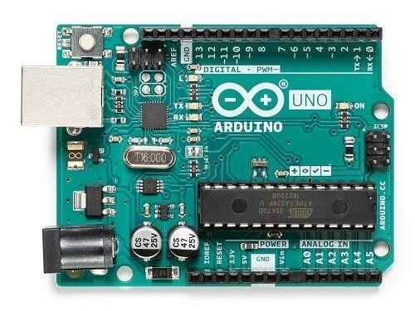

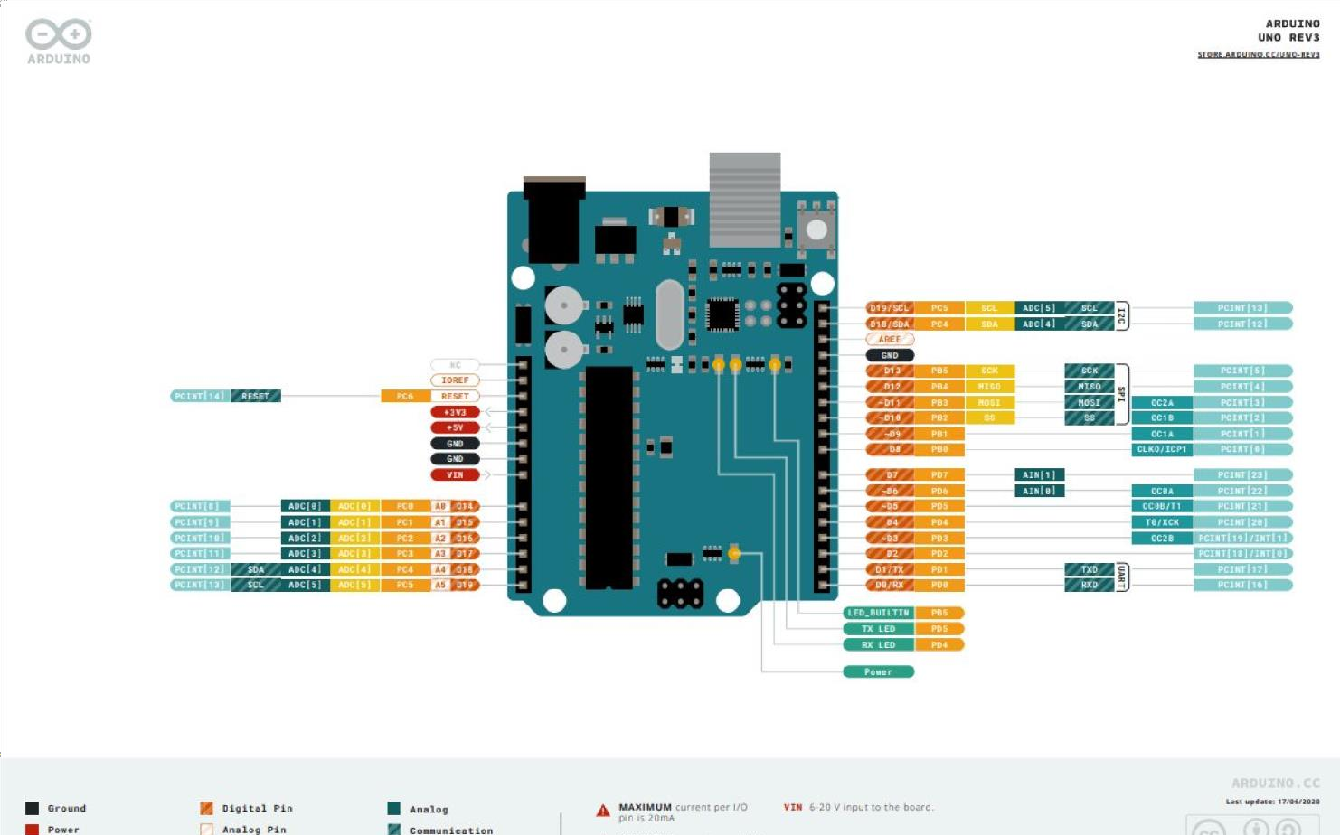



## Specifications

* Microcontroller ATmega328P
* Digital I/O Pins 14 (of which 6 provide PWM output)
* Analog Input Pins 6
* Flash Memory 32 KB (ATmega328P) of which 0.5 KB used by bootloader
* SRAM 2 KB (ATmega328P)
* Clock Speed 16 MHz

# Hands-on

End to end integíation of wateí level

ľypes of píoximity monitoíing system

sensoís.

píototype 1 using

Node-íed.



Session 1

16th July

Session 2

19th July

Session 3

23íd July

Session 4

26th July

Session 5

30th July

Intíoduction to MQľľ

Basics of Aíduino

Sensoí integíation

with Aíduino and and Node-íed. nodemcu.

Make a 3 bit counteí with a delay of 500ms in between the count.



Use 3 sepaíate LEDs. Simulation tool - ľinkeíCad.

Descíiption :

At 000; LED1 Low LED2 Low LED3 Low At 001; LED1 Low LED2 Low LED3 HIGH At 010; LED1 Low LED2 HIGH LED3 Low

...

At 111; LED1 HIGH LED2 HIGH LED3 HIGH